**Final Project Proposal**

**CMST 386 | Mariah St. Jeor**

1. **Client and Topic**
   1. My website is for my home-based business that I run. This will be a blog that I have dedicated to moms/parents, military spouses, as well as a site for homegoods that I sell and my pampered chef consulting. I imagine it having a dedicated blog space, shopping, recipes, and video tutorials.
2. **Development Process and Engagement**
   1. This website is for myself. I want to research other blog sites and small business sites to see how they set it up; especially if there are many topics being shared across the website. Researching other sites as well as website templates and plans will help. Along with research I will plan well by making wireframes and visual plans before creating to ensure I’m not lost while creating it. The research will help with a plan and that way it will be easier to execute.
3. **Testing**
   1. I think a great way to test is to do some usertesting by myself and a few others. It would be helpful to create a list of tasks that one might want to perform and have someone go through the site to complete the tasks. Having them say out loud their process will help me know what a user might be expecting to do in order to make it as user friendly as possible.
   2. I would like to include Chrome, Edge, and Safari since those are probably the most used (at least for me and what seems like my audience).
4. **Description**
   1. The business is Mommi & E. A community for parents and military families to learn, get advice, purchase fun things, and connect with others. The goal is to help out families and parents with life, whether it is helping with meals, or just giving some life tips and tricks.
   2. The website is key to the business because it is the central point for all the information shared on social media and elsewhere. It’s where purchases are made, inventory is kept, and where people are directed.
   3. The main target audience is parents, but mainly moms. This person is a fairly young mom that turns to social media and the internet for mom hacks, life help with cooking and caring for her kids, as well as finding gadgets to help with these things. This would most likely be a middle-class person with moderate to no education who has experience with technology/websites and media on at least a weekly basis.
   4. The website needs to be designed for someone who may not be super tech-savvy. It needs to be simple and user-friendly. The overall look should also be welcoming and happy with a light-hearted feel because it is geared towards parents and families.
   5. The website will contain content that is pretty much all made or written by me. It will contain a blog that I write, information about products that I sell, and media that I create as well.
   6. The content of the website will need to be updated very frequently. At least weekly I would be uploading new content whether it is a product, video, or blog post.
5. **Growth and Maintenance**
   1. I think there are a few ways that the website could evolve. If enough people start to follow and use the website, it could be turned into a community and pages could be added for people to connect (like forums). With new blog posts always being made and new products coming out, there will also be other things evolving.
   2. I’m not totally sure what can be done to make things easier, but I’d imagine there are ways. I can add things to the website that will make it easier to change in the future. I’m imagining something like clean layouts so that you can always follow the same pattern, keeping all the code clean and easy to read, and just generally staying organized with everything used to create the site.
   3. To maintain the website it will need to be updated, but also kept up to date with visuals and templates. Some tasks would include organizing blog posts, using trends with products, and frequent user testing as things evolve.
   4. Updates to the website will be added weekly. Once a month, it would be good to re-organize and clean things up as well. This could include checking on the way things are organized or setup in the store and the blog.
6. **Wireframe**: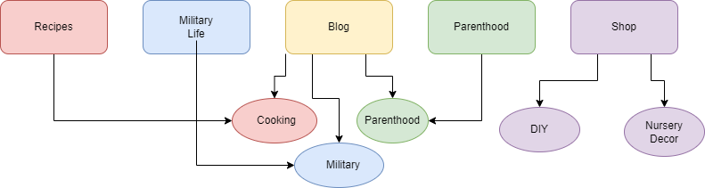
   1. The website will be broken into five main pages: Recipes, Military Life, Blog, Parenthood and Shopping. Recipes, Military Life, and Parenthood will all have sections that link to the blog posts of that section. The shop section will be it’s own. The blog is broken into the other categories and featured on those pages, but it is home to all the blog posts.
   2. Navigation bar will include these 5 pages. The blog and shopping pages will have a drop down menu. Each page will have sections such as blog posts, highlights, social posts, and links. The recipes will be broken into sections as well.
7. **Web Hosting**
   1. There are many things to consider with hosting such as price, storage, convenience, speed, security, cutomer support and more. I think it’s important to pick out what is most important to you. If you don’t know a lot about building a site, it may be more important to you to have an easy to use program, or if you have a tight budget you need something cheaper. For me, I would want to consider price and ease the most, but at some point I know it would be important to consider storage and traffic. In the past I have used things easy to use like wix or square, but I know github works well if you know your coding and such.
   2. For my site I need a shopping cart option as well as a good blogging system. For example, square worked well for me for selling, but their “stories” feature is not in depth enough to actually create a good blog. I’m sure there might be a few others that I’m not aware of or can’t think of with my lack of knowledge on the subject.
   3. I would say that it would be best to be able to support html/css and javascript as those are what I would use.
   4. I want to use mommiande.com. I actually own this domain right now since I’m working on making a website for it. This is the name of my business.
8. **Marketing**
   1. I think SEO and ads are a great way to market a site right now. SEO takes a bit of practice and research, but works. I can market my site with ads on facebook and youtube as well as advertising myself on pages, groups, etc.
   2. SEO planning should start well before the site is launched. I think some of the best things to do is knowing and keeping track of keywords, writing good content, and using keywords as you go.
9. **Security**
   1. Yes, my site will include an e-commerce component.
   2. There will not be any password protected content because it will all be there for the public and I don’t have anything for exclusive people.
   3. No, users will not ever need to make an account for anything.